### Example assessment questions for object detection

Question

What is the **recall of class A** given the following confusion matrix? Please express your answer as a decimal rounded to 3 decimal places (For example, 0.6825 would be 0.683).

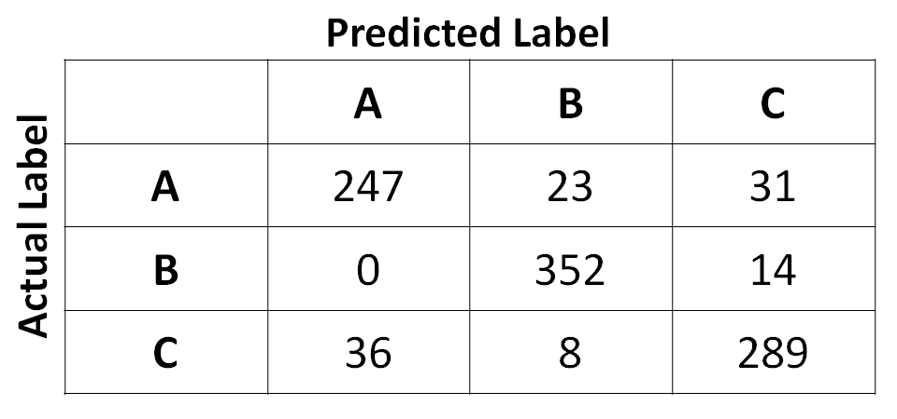

The per-class recall is calculated by the following equation:

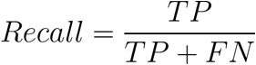

Answer: 0.821

Explanation: You calculate recall as follows: 247 / (247 + 23 + 31) = 0.821.

Question

Let’s say that we train a binary classifier to identify “dogs” vs. rest. We create a histogram of the results of the test set in the plot shown below. If we set the initial decision threshold to 0.5, we get the true negatives, false negatives, true positives, and true negatives as shown. What happens to **precision** as we move the decision threshold up (say, to 0.7)?

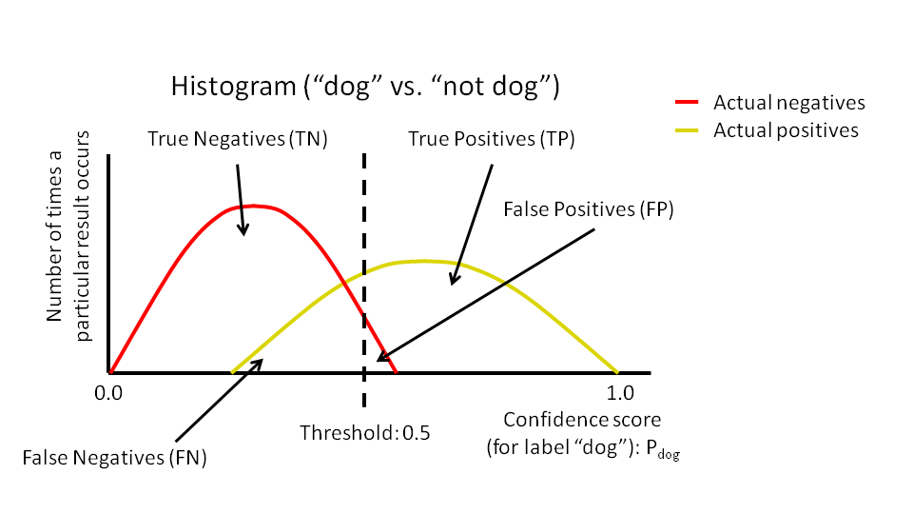

Remember that precision is the proportion of positive predictions that was actually correct. Here is the equation for solving for precision:

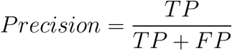

1. **Precision will increase**
2. Precision will decrease
3. Precision will stay the same
4. Precision will invert

Explanation: As the threshold increases, false positives (FP) will decrease, which means the proportion of TP / (TP + FP) will tend toward 1. Another way of saying this is that the proportion of predictions that was actually correct will increase.

Question

Given the following precision-recall graph (measured from a test set), calculate the **average precision (AP)**. Please express your answer as a decimal rounded to 3 decimal places (For example, 0.6825 would be 0.683).

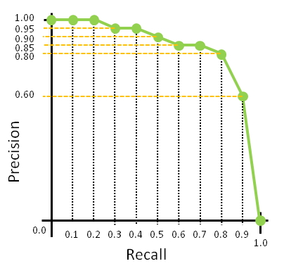

You should use the PASCAL Visual Object Classes Challenge (2009) definition of average precision, which is calculated by the following equation (which states that the average precision is the mean of the precision values as measured from 11 equally spaced recall values from 0.0 to 1.0):

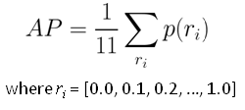

Answer: 0.809

Explanation: We get this by calculating the mean of all precision values from the green dots on the graph: (1.00 + 1.00 + 1.00 + 0.95 + 0.95 + 0.90 + 0.85 + 0.85 + 0.80 + 0.60 + 0.00) / 11 = 0.809

Question